15U ENCLOSURE 19" CABINET 600X800 FLOOR STANDING DATA RACK - ECO NETCAB
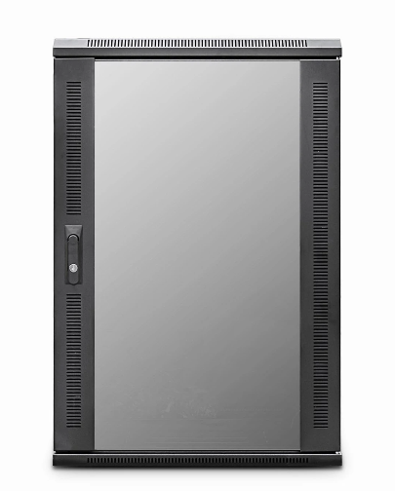

DESCRIPTION
Small-Scale, Quality Networking Deployment - Competitively Priced
Looking to deploy a small-height data or telco cabinet but need the
advantages of a full height cabinet but don’t need a fitted fan tray?
The newly designed EcoNetCab 12U and 15U floor-standing cabinets are ideal for
many installations that need all the advantages for full width, 19-inch racking,
full depth, adjustable mount posts but does not include a fitted fan tray, thus keeping
your costs to a minimum. Of course our other accessories including castors, jacking
feet and M6 cage nuts and bolts.
With more networking, telco, PBX and broadcast equipment becoming more
compact and of course thinking all installations do not require a high,
towering 42U cabinet for example, the new EcoNetCab 12U and 15U range are
ideal for IT rooms, PBX switching centres, SME business applications, but without the
extra height clearance needed.
Superb-build quality of course is assured, multiple cable entries, together
with left/right hinged safety-glass door as standard, together with a hard-wearing
black, powder-coated finish and assembled here in the UK..

SPECIFICATIONS
15U high 600W 800D
ETSI 19” front/rear profiles, adjustable
Lockable vented glass door, reversible
Removable side panels, rear lockable door
Ideal for SME, IT
Supplied with Shelf, Roof mount Fantray, fitted castors and jacking feet (4)
UK Assembled and quality assured

TECHNICAL INFO
SKU/MPN: CAB-FE-15U-68
EAN: 8400800034625
Weight: 50 Kg
Dimensions: 600(width) x800(depth) x860mm(height)

FILES
Specification Sheet (PDF)

